V-Model
Lifecycle Process Model
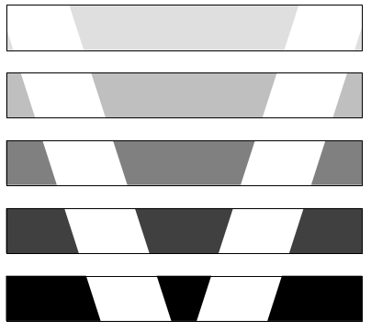

Brief Description

The V-Model as Software Development Standard
Project Management
Configuration Management
Quality Assurance
Software Development
Procedure
Methods
Tool Requirements

The Three-Level Standardization Concept
Today, the necessity for standardization in software development is undisputed; buzzwords such as "engineering software development" are quoted daily.
Less unique is the answer to the question how detailed and on which level standards are to be applied in a concrete project.
The value of a standard here is the extent to which the following objectives can be achieved with the help of standardization measures:
- reduction of software costs in the entire lifecycle,
- improvement/warranty of software quality,
- improvement in communication between customer and contractor.
The standardization concept of the German Federal Authorities pursues this objective by regulations on three levels:
- procedure,
- applicable methods,
- functional requirements applied to tools to be used.
The individual standardization levels regulate the following situations:
1. Procedure
"What has to be done?"
What is to be determined here is which activities have to be carried out in the process of the development of software, which results have to be produced in this process and which are the contents that these results have to have.
2. Methods
"How is this to be achieved?"
What is to be determined here is with which methods the activities laid down for the first level are to be carried out and which presentation means are to be used in the results.
3. Tool Requirements
"What is used to do something?"
What is determined here is which functional characteristics the tools have to have, which are to be used in the development of software.
On all levels, the regulations are structured according to activity areas:
- software development,
- quality assurance,
- configuration management,
- project management.
For each level, a development standard was drawn up by the Federal Authorities.
In this overview, the lifecycle process model (V-Model) is described as the standard for the first level. It regulates the software development process in a uniform and binding way by means of activities and products (results), which have to be taken into consideration during software development and the accompanying activities for quality assurance, configuration management and project management.

Three levels of standardization
There is an activity description for each activity in a kind of task description. There is a document description for each document, which defines the structure and contents of the document.
Possible Applications of the V-Model
The V-Model was developed from a variety of applicative aspects. The focal points of use are:
- Contractual Basis
In this instance, the scope of delivery of the software and the completeness of the software documentation are clearly defined.
- Work Instruction
The lifecycle process model serves as guideline and concrete work instruction for software development with its detailed descriptions of the activities and documents.
- Communications Basis
By means of the description of the documents and the provision of a glossary, it serves as the basis for mutual understanding and reduces frictional losses between customer, user, contractor and developer.

The V-Model in the Public Authorities Domain
The lifecycle process model was originally developed by IABG in Ottobrunn, near Munich, in cooperation with the Federal Office for Defence Technology and Procurement in Koblenz, for the Federal Ministry of Defence. It was taken over by the Federal Ministry of the Interior for the civilian public authorities domain in summer 1992. Hence a uniform standard for the whole range of public authorities exists.
The V-Model in Industrial Use
The provisions of the lifecycle process model are strictly organizationally impartial. It is restricted exclusively to the technical development process. Therefore, the lifecycle process model is not only suitable as the development standard in public administration but also in industry. It already has been taken over and is used as the company standard by a number of companies and is used both by software and system houses and also by users from many other different areas such as
Federal Ministry of the Interior

Planning and Realization
of IT-Projects

V-Model
Software Lifecycle Process Model
August 1992

KBSt
V-Model cover page
for the civilian area
- banks,
- insurance companies,
- car manufacturers,
- manufacturing industry,
- energy producers.
The use of the lifecycle process model in the industrial domain is made considerably easier by the fact that its use is free of license fees. It is non-proprietary and not copy-protected, which means that the lifecycle model can be copied as often as is wished for one's own use without infringing licence regulations.
General Directive 250

Software-Development Standard for the Federal Armed Forces

V-Model
Software Lifecycle Process Model
August 1992

V-Model cover page
for the defense area
V-Model on the European Level
An English translation of the lifecycle model was completed for use in international projects. This is also the subject of an EC project (EURO- METHOD), which was started in 1989 with the aim of surveying software engineering methods and their harmonization. The German representative in the EC Committees is the Federal Ministry of the Interior. In view of the Ministry's own use of the V-Model, it has tabled it as the German standardization contribution at the European level.

Specific Consideration of Special Usage Aspects
The V-Model takes into consideration:
- the requirements for certification of software according to IT-security criteria;
- the particular features of detailed information modelling as required for the development of information systems;
- the interactions between software and procedure definition, as these are to the fore in the development of information systems;
- the particular features of critical realtime software, as they are used especially in embedded computer systems (ECS) applications;
- the interactions between software and hardware in the development of ECS software.
V-Model and QA Standards
The V-Model fulfils the requirements of the NATO standards AQAP-13/
AQAP-150 as software development and quality assurance standards when used in the defence technology field.
In the whole public authorities dom-ain, the most significant technical "Minimum Requirements for Use of Information Technology" of the Federal and State Audit Offices are fulfilled when the V-Model is applied correctly.
In the industrial environment, the application of the V-Model guarantees the fulfillment of the technical requirements of the Standards in the ISO 9000 series (in the software-related interpretation of ISO 9000-3) and thus is of assistance and a basis for ISO 9000 certifications.
V-Model Safety and
Security
The V-Model contains regulations which are necessary for the development of "critical" software. The term criticality refers on the one hand to aspects included in the term "safety" and, on the other hand, to confidentiality aspects (security).
The current valid IT-Security Criteria (ITSEC) are fulfilled with respect to their regulations for the development process by the application of the V-Model. Certification of the software developed in this way has been considerably facilitated.
Where and How Obtainable
The V-Model can be obtained from the following places in Germany:
- BMVg – FÜS I -1
Postfach 1328
D-53003 Bonn
(for the defense domain)
- Bundesanzeiger-Verlagsgesellschaft mbH
Postfach 10 05 34
D-50445 Köln
(volumes 27/1 and 27/2 of the KBSt-publication series, civilian version)
- IABG, Dept. ITE
Einsteinstr. 20
D-85521 Ottobrunn
(civilian and defense versions)
To facilitate use in projects, the V-Model is available not only as hardcopy but also on diskette and magnetic tape.
Participation of the
Users in the Development and Maintenance of the V-Model
Both the industrial and the public authority users of the V-Model were involved in the development and maintenance process by the convening of expert groups.
The necessary user influence on the maintenance and change process of the V-Model is guaranteed by a Change Control Board with annual meetings. It consists out of representatives of industry associations and public authorities.
The Change Control Board is obliged, according to its standing orders, to deal thoroughly with all incoming change requests which are submitted to it.
Explanatory Appendices to the V-Model
Besides the actual regulations part, the V-Model contains three appendices:
- Appendix 1 "Explanations to the V-Model-Application". This explanatory section provides background information and facilitates familiarization.
- Appendix 2 "Explanations of the Products". Detailed explanations to the required content are given for each product (software, doc-ument) defined in the V-Model.
- Appendix 3 "Specific Public Authority Supplements". This appendix is different for the defense domain and civilian domain. Basically what is presented here is how the V-Model is to be applied in conjunction with the valid superordinate regulations in the respective domain (e. g. global phase framework in the defense technology domain and "Special Contractual Regulations for Federal and State authorities (BVB)" in the civilian domain).
Adaptation to the Project Needs: "Tailoring"

An outstanding feature of the V-Model is its universal validity and its company and project independence. It is therefore independent in terms of the area where it is used. To use it for a specific project, individual decisions have to be taken with respect to which activities and documents are necessary for the project for factual reasons. In each case, superfluous mountains of paper, senseless documentation, but also the lack of important documents are to be avoided. This project-specific adaptation is called "Tailoring".
Tailoring is conducted in two stages:
- In the "contractual tailoring", which is carried out before conclusion of the contract and start of the actual project, a selection of the necessary activities and products is to be undertaken. In addition, special "deletion"-conditions are established under which certain activities which were held to be essential at the beginning can be deleted under particular circumstances in the course of the project. The resulting subset of the V-Model is laid down together with further agreements in the Project Manual. This Project Manual is an important part of the contract.
The contractual tailoring is also important even if a project is not externally awarded but is an in-house development.

- The "technical tailoring", the deletion conditions laid down in the Project Manual are evaluated and it is decided, which of the activities contained in the Project Manual are to be conducted. This occurs continuously during the project.
V-Model as Contractual Basis
So that comparability of all offers with respect to the kind of project execution and documentation is comprehensively guaranteed, the project-specific adaptation of the V-Model for external contractual awards is undertaken before tendering begins.
Contractual Tailoring
at project initialization

Technical Tailoring
conducted during the project
Steps in Tailoring
Following of the project specific implementing conditions.
Decide what activities and products have to be carried out/produced
collection of all other important regulations for the project
Selection of required
activities and products
Project Plan
Project Manual
V-Model
The Project Manual thus compiled defines the scope of the project to be realized by the contractor (and his sub-contractors). The Project Manual therefore becomes the uniform action basis and guideline for all participants in the project.
As particular project characteristics for certain application areas are the same in public authority and industry use, easy applicable forms for activities and product recommendations are proposed as standardized pre-tailoring for frequent project types. Thus the tailoring procedure can be considerably simplified.
selection recommendations
or deletion conditions
Use of the V-Model in Projects

Organizational Embedment
The V-Model knows different roles which are defined by the necessary experience, knowledge and capability for the project tasks.
The allocation of roles to activities in the V-Model is described in a matrix for each of the sub-models SWD, QA, PM and CM, whereby several roles can be allocated to one person. These regulations make no statement concerning the fulfillment of the roles by organizational units or persons. Thus the independence of the V-Model from organizational and project-specific boundary conditions is achieved.
The allocation of roles to organizational units/persons has to be carried out individually at the start of the project.
Support of the Users When Using the V-Model
In order to support the users of the V-Model and other software standards, IABG has concluded a cooperation agreement with Deutsche-System-Technik GmbH (DST) in Kiel/Bremen. As part of IT-Application Support, both companies support the V-Model users with
- training,
- introduction and
familiarization,
- company-specific adaptation,
- appraisal of development documentation.

Offer of Training
A series of tried and experienced training concepts exist for the implementation of the V-Model with the adequate degree of detail for the user needs.
Tool Support for the Life Process Model
The application of the V-Model can be considerably facilitated by the use of tools.
The functionality of such tools should comprise at least
- tailoring,
- guidance through the project activities and
- generation of documents.
For this purpose, the software development tools are to be adapted to the activities and documents of the V-Model.

Roles in the V-Model
Increasingly, tool manufacturers are integrating the activities and products of the V-Model into their tools as a result of the wide use of the V-Model in the defense area, Federal public administration and industry.
Degree of Maturity of the V-Model
Work on the V-Model has been going on since 1986. From about the beginning of 1990, pilot trials in projects were begun, before it was made obligatory for the defense area by the Federal Ministry of Defence in February 1991. At that time, many firms, which are active in both the defense technology and commercial domains, used the V-Model for software projects. Against the back-ground of the trials and the repeated updating, taking the experience into consideration, what can be determined is that the V-Model can be seen as sophisticated and approved.

Structuring the V-Model in Submodels

The V-Model is structured into functional parts, so-called submodels. They comprise the software development (SWD), quality assurance (QA), configuration management (CM) and the project management (PM). These four submodels are closely interconnected and mutually influence one another by exchange of products/results.
.
Software-
Development
P2
Project-
Management
Quality
Assurance
Configuration
Management
Example for the activity and product flow within the four
submodels
A2
A3
P1
A1
P5
P4
P6
P3
A4
A7
A6
A5

- PM plans, monitors and informs the submodels SWD, QA, and CM.
Interaction of the Submodels
- SWD develops the system or software.
- QA submits quality requirements to the submodels SWD, CM and PM, test cases and criteria and assures the products and the compliance of standards.
- CM administers the generated products.

The V-Model describes in detail the interfaces between the submodels SWD and QA, as software quality can only be ensured by the consequent application of quality assurance measures and by checking if they are complied with.
PM
QA
SWD
informs
controls/
monitors
plans
assesses
provides
QA requirements
methods
develops
system/
documentation
Of particular relevance for real-time software is the criticality, that is, the classification of software with respect to reliability and security. In the V-Model this is considered a quality requirement and is precisely regulated. Mechanisms are proposed how the expenditure for development and assessment can be adapted to the different levels of criticality of the software.
CM
administers
– configurations
– products
– access rights
– changes
Submodel "Software Development" (SWD)

The submodel SWD regulates which activities are to be carried out during software development, and when which products(documents, code) are to be prepared.
The submodel SWD comprises the following main activities:
System Requirements Analysis and Design (SWD 1)
- Description of the requirements of the system and its environment. Conduction of a threat and risk analysis, development of a security concept. Delivery of a user level model of functions/data/ objects. Structuring the system into subsystems, segments or configuration items.
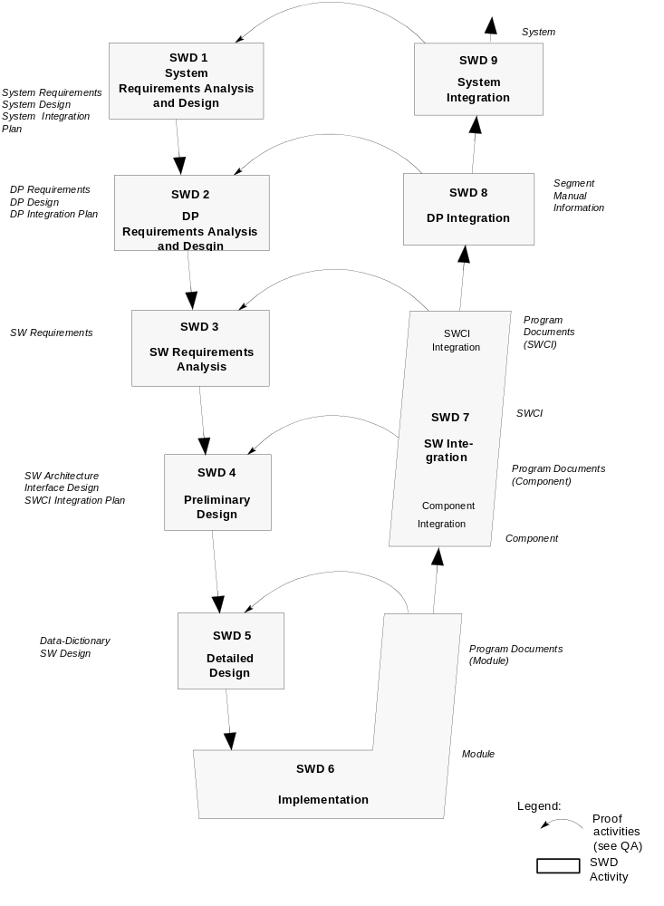
Activities and Products in the Submodel SWD
DP Requirements Analysis and Design (SWD 2)
- Description of the requirements of a DP segment and its environment, development of a security model, structuring the segment into its SW and HW configuration items (SWCI, HWCI).
SW Requirements Analysis (SWD 3)
- Description of the requirements of a SWCI and its environment.
Preliminary Design (SWD 4)
- Structuring of the SWCI in SW components/modules/database, specification of the interfaces and interaction of its elements.
Detailed Design (SWD 5)
- Description of the components and modules with respect to the real implementation of their functions, the data administration and error handling up to a programming specification.
Implementation (SWD 6)
- Conversion of the programming specifications to statements of the (chosen) programming language, informal assessment of developed code and implementation of a database (if existing).
SW Integration (SWD 7)
- Integration of modules to components and of components to the SWCI.
DV Integration (SWD 8)
- Integration of the different SW and HW configuration items to a DP segment.
System Integration (SWD 9)
- Integration of the subsystems (if existing) and segments to the system.

Submodel "Quality Assurance" (QA)

The submodel QA regulates the tasks and functions of the quality assurance within the software development process.
In contrast to the informal assessment of the submodel SWD the procedures established in the submodel QA ensure the fulfillment of the requirements which are specified in the documents System Requirements, DP Requirements, and SW Requirements of the submodel SWD.
The regulations however, do not affect (as it is also the case for the other submodels) organizational stipulations.
The submodel comprises the following main activities:
QA Initialization (QA 1)
- The QA initialization defines the organizational and procedural framework in the QA Plan and the assessment plans.
Process Assessment of Activities (QA 2)
- During the process assessment what is checked, is if prescribed procedures are complied with during the performance of specific activities.
Assessment Preparation (QA 3)
- The preparation of assessment includes the set up of Assessment Specification and Procedure and the completion of the Assessment Plan by the Assessment Environment. The assessment criteria must be defined so that an assessment of successful performance can subsequently be evaluated.
Product Assessment (QA 4)
- The product assessment takes place in two steps: assessment with respect to the formal criteria and the contents of the product. The SW code is to be assessed according to the Assessment Specification and Procedure. The result is recorded in an Assessment report.
Phase Review (QA 5)
- The purpose of the phase review is to decide, if the next SWD main activity can be started.

Activities and Products in the Submodel QA

What has to be determined is if all planned products are available in the form required, if costs and schedules have been complied with and if the following activities are properly planned.
Off-the-shelf Product Assessment (QA 6)
- This assessment shall indicate, if the quality requirements are fulfilled by a non-developmental product.
QA Reporting (QA 7)
- The Assessment Reports are to be evaluated in regular intervals according to specified criteria and the results submitted to PM.

Submodel "Configuration Management" (CM)

The submodel CM ensures that all products are uniquely identifiable, that interrelations and deviations of different versions or variants of a configuration remain evident and that any product changes can be made only in a controlled manner.
The submodel CM comprises the following main activities:
CM Initialization (CM 1)
- The CM initialization regulates the organizational and procedural framework within the CM Plan. Furthermore, the resources (product library, tools) are to be provided.
Configuration Administration (CM 2)
- The configuration administration comprises the administration of products, configurations and rights. The administration of a configuration is handled via the Configuration Identification Document (CID), which provides an overview of the structure of the configuration and the actual state.
Change Management (CM 3)
- Error reports, problem reports, proposals for improvement, etc. are recorded and administered and submitted as change requests. The Change Management monitors the change procedure.
The implementation of a change itself is carried out according to the regulations of the V-Model.

Data Backup (CM 4)
- Backups within the project are due at fixed times and scope.
Activities and Products in the Submodel CM

CM Reporting (CM 5)
- For preparing the phase reviews and for information of the project management, relevant reports are to be generated.
Submodel "Project Management" (PM)

The submodel PM regulates the tasks and functions of the project management within the software development process. These regulations do not affect the organizational structures in any way and are different from the function of the system management.
The tasks determined in the submodel PM comprise the planning, control and monitoring of project-internal activities, the interface to project-external units and project-internal roles, the project representatives and the project information center.
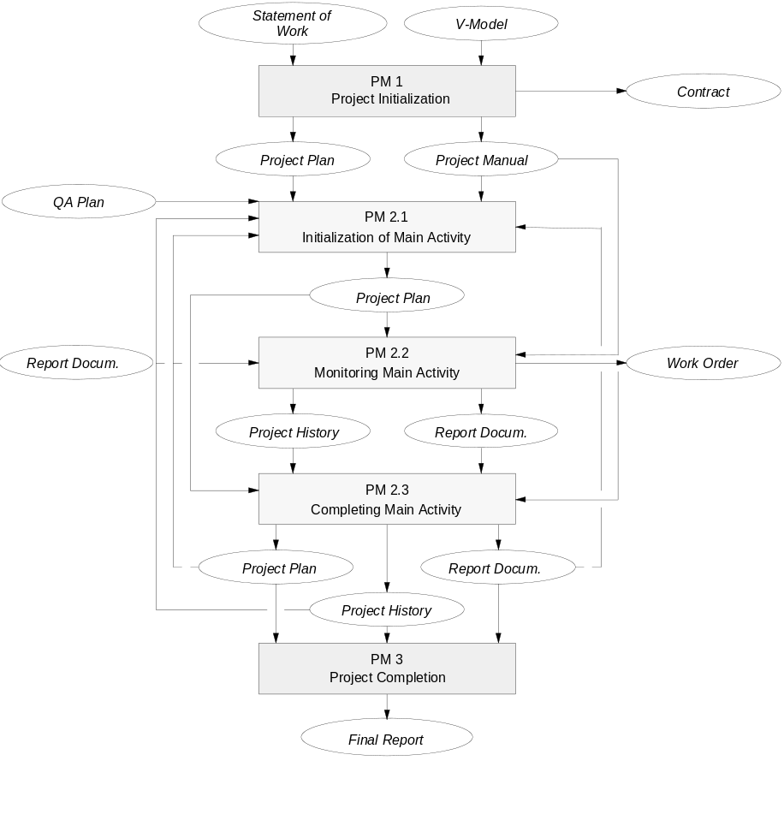
Activities and Products in the Submodel PM
The submodel PM comprises the following main activities:
Project Initialization (PM 1)
- The initialization regulates the organizational and procedural framework in a Project Plan and in a Proj-ect Manual. The modalities of the project-internal cooperation as well as the interface to customer and subcontractor are to be fixed. For the project manual specific goals and limiting conditions are to be determined as the basis for the tailoring, that is, the project-specific adaptation of the V-Model. The Project Plan includes preliminary planning in respect of project organization, cost, baselines, milestones, scheduling and personnel planning. Further-more a preselection of a development environment has to take place.

Project Monitoring (PM 2)
- Within the scope of project monitoring, the project management has to take account of detailed planning, monitoring, and control as well as information service on the activity and subactivity level. These means form the framework around the individual subactivities of a project including the parts
· initialization
· monitoring
· completion.

Project Completion (PM 3)
- At the end of a project, a final report has to be submitted which includes a summary of the course of the project, an explanation of the results achieved, and a comparison between actual status and the intended plan.
The Advantages at a Glance

Advantages of the Process
Standardization

- Improved communication among the
persons involved in the project
- Uniform procedure in public authorities
and commissioned industry
- Guarantee of better product quality
- Productivity increase by the reduction of
familiarization and training times
- More precise calculation of new
projects using standardized procedures
- Less dependencies on persons and companies

Reduction of Maintenance and
Change Problems

- Decrease in maintenance cases
resulting from improved product
quality
- Decrease in the maintenance effort
resulting in the existence of an
adequate software documentation
and an easier understanding
because of the uniform structure

IABG
Industrieanlagen-
Betriebsgesellschaft mbH
Einsteinstr. 20
D-85521 Ottobrunn
Telephone +49-89-6088-2369 or -2368
Telefax +49-89-6088-3355 or -3418
Telex 5 24 001

Version: February 1993

Release: 1995

The V-Model

- is complete
all functional areas (Software Development,
Quality Assurance, Configuration Management,
and Project Management) are covered
- provides concrete assistance
contains many instructions and
recommendations; gives detailed explanations
on special problems and on the individual
necessary task results
- is sophisticated
participation of users from industry and public
authorities in the generation and in the change
process of the V-Model
- is balanced/not manufacturer-specific
è good acceptance
no influence or dominance of industrial
lobbyists
- supports when tendering
the complete presentation of the development
documents and the tailoring procedure
provides good support in the awarding of the
contract process
- public controlled updating
further development under the supervision of a
Change Control Board with industry and public
authority representatives
- wide application spectrum
as a result of the application in the whole
defense domain, the whole public
administration area and by the industrial
IT-suppliers, a wide application area is guaranteed

Your Contact:

in Ottobrunn: Tel. +49-89-6088-3921

